**PIZZA SALES SQL QUERIES**

**KPI’s**

**1. Total Revenue**

select sum(total_price) as Total_Revenue

from pizza_sales;

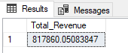

**2. Average Order Value**

select (sum(total_price)/ count(distinct order_id)) as Average_Order_Value

from pizza_sales;

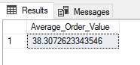

**3. Total Pizzas Sold**

select sum(quantity) as total_pizzas_sold

from pizza_sales;

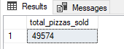

**4. Total Orders**

select count(distinct(order_id)) as total_orders

from pizza_sales;

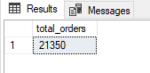 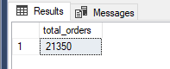

**5. Average Pizzas per order**

SELECT CAST(CAST(SUM(quantity) AS DECIMAL(10,2)) / CAST(COUNT(DISTINCT order_id) AS DECIMAL(10,2)) AS DECIMAL(10,2)) AS avg_pizzas_order

FROM pizza_sales;

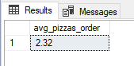

**6. Daily Trend for Orders**

select DATENAME(dw,order_date) as order_day, count(distinct order_id) as total_orders

from pizza_sales

group by DATENAME(dw,order_date)

order by total_orders ASC;

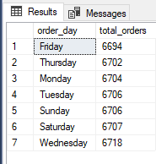

**7. Hourly Trend for Total orders**

select DATEPART(HOUR, order_time) as order_time, count(distinct order_id) as total_orders

from pizza_sales

group by DATEPART(HOUR, order_time)

order by DATEPART(HOUR, order_time) ASC;

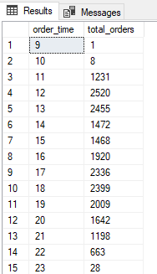

**8. Percentage of Sales by Pizza Category**

-- Percentage of Sales by Pizza Category

select pizza_category, cast(sum(total_price) as decimal(10,2)) as Total_Sales,cast(sum(total_price) * 100 / (select sum(total_price) from pizza_sales where MONTH(order_date) = 1) as decimal(10,2)) as Percentage_of_Sales

from pizza_sales

where MONTH(order_date) = 1

group by pizza_category

order by Percentage_of_Sales;

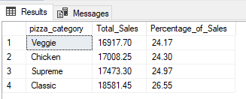

//where MONTH(order_date) = 1

This line is used to extract data from month of January, we can target any month by changing the number.

**9. Percentage of Sales by Pizza Size**

select pizza_size, cast(sum(total_price) as decimal(10,2)) as Total_Sales,cast(sum(total_price) * 100 / (select sum(total_price) from pizza_sales where DATEPART(quarter, order_date) =1) as decimal(10,2)) as Percentage_of_Sales

from pizza_sales

where DATEPART(quarter, order_date)=1

group by pizza_size

order by Percentage_of_Sales desc;

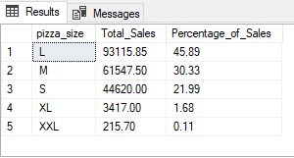

// where DATEPART(quarter, order_date)=1

Used for quarters

**10. Total pizza sold by pizza category**

select pizza_category, sum(quantity) as total_pizzas_sold

from pizza_sales

group by pizza_category

order by total_pizzas_sold;

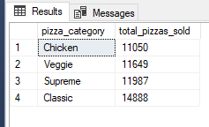

**11. Top 5 Best sellers by Total Pizzas Sold**

select top 5 pizza_name, sum(quantity) as total_pizzas_sold

from pizza_sales

group by pizza_name

order by total_pizzas_sold desc;

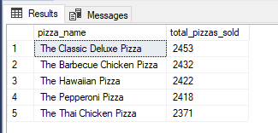

**11. Bottom 5 Worst sellers by Total Pizzas Sold**

select top 5 pizza_name, sum(quantity) as total_pizzas_sold

from pizza_sales

group by pizza_name

order by total_pizzas_sold asc;

